

Configuring VPN for a Fortinet Firewall Environment

Rui Zhao, CCNA
Purpose:

The purpose of configuring VPN for a Fortinet Firewall Environment is to add an extra layer of encryption security to the network, along with the ability to remotely access your desktop from another device.

Background Information:

In 2000, a cybersecurity company Fortinet was officially founded in Sunnyvale, California by brothers Ken and Michael Xie. After marketing and selling their first product, a physical FortiGate firewall, they have expanded their expertise and products in access points, security, and sandbox technology. Today, Fortinet has become one of the most prominent cybersecurity companies, serving over 900,000 customers globally, with 15.9 million units of products at the end of 2025. Additionally, they offer next-generation firewalls that have features such as wireless LAN, FortiGuard AI-powered security services, and SaaS solutions for management.
Fortinet is a security ecosystem and offers many sorts of different products and services. They emphasized in integrating wireless systems into next-generation firewalls, offering different features in order to control the network and cybersecurity. With their integration of the cloud, further expanding their significant role in the ever-growing enterprise IT infrastructure, getting access to cloud providers such as AWS, Microsoft Azure, and Google Cloud Platform. Furthermore, Fortinet has its own cloud-native security tools, called the FortiCNAPP platform, allowing security management with the many different cloud providers.
Comparing Fortinet to other firewall vendors, Fortinet heavily focuses on integrating products together. Furthermore, using multiple Fortinet products will further increase security and threat detection. It isn’t only suitable for SOHO environments, but also enterprise-grade solutions for large organizations.
Fortinet also directly competes with the leading competitors like Cisco, Palo Alto Networks, and Check Point. Combining many different Fortinet systems and ecosystems will grant you access to many different features.
The Fortinet VPN (virtual private network) is a feature that allows masking your internet protocols to establish a private connection from a public Wi-Fi connection. The normal WiFi network connection is typically on the unsecured side due to being able to have personal information potentially exposed to other parties, which usually have malicious intensions. VPN helps protect against this by making an encrypted tunnel for to and from data, which is safe from hackers and malware.
Using the VPN allows improved security overall with the firewall, along with the access for remote access. They also provide safe data sharing between individual hosts, along with improving the total cost of ownership when it comes to security costs compared to traditional companies.
The use of SSL VPN also allows encryption under the SSL/TLS feature to have access to remote access under a secure tunnel. This simplifies remote connectivity and allows safe and secure security and access control.

Lab Summary:

In this lab, we utilized the Fortinet management interface to create VPN tailored for SSL/TLS encryption in order to protect and encrypt our network along with being granted the opportunity to have remote access control from one external PC to another PC.

Lab Commands:

First, we should define a user group for our remote access users. Head over to User & Authentication User Groups Create New.

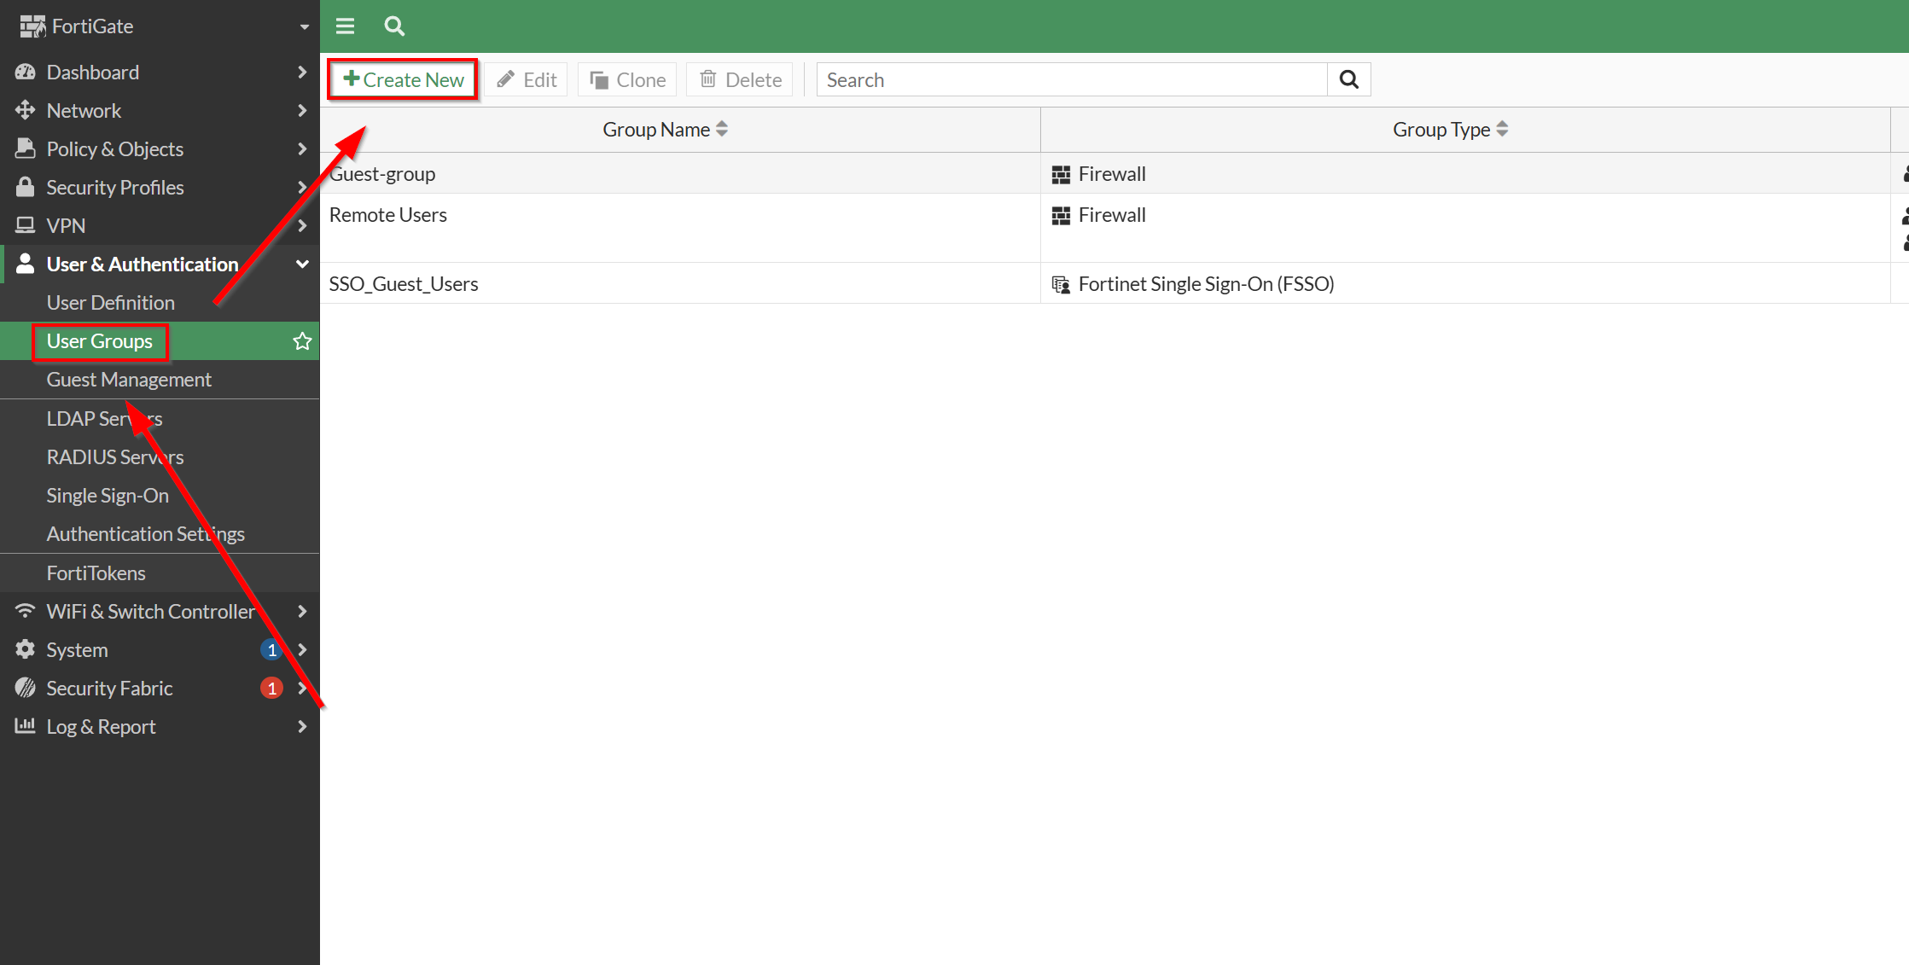

Then, give our Remote User group a name, then select Guest as its type. We want to change the expiration so that remote user clients won’t lose connectivity in just the default 4 hours. For demonstration, we have put in 70 days. After you are finished, press OK to proceed to the next step.

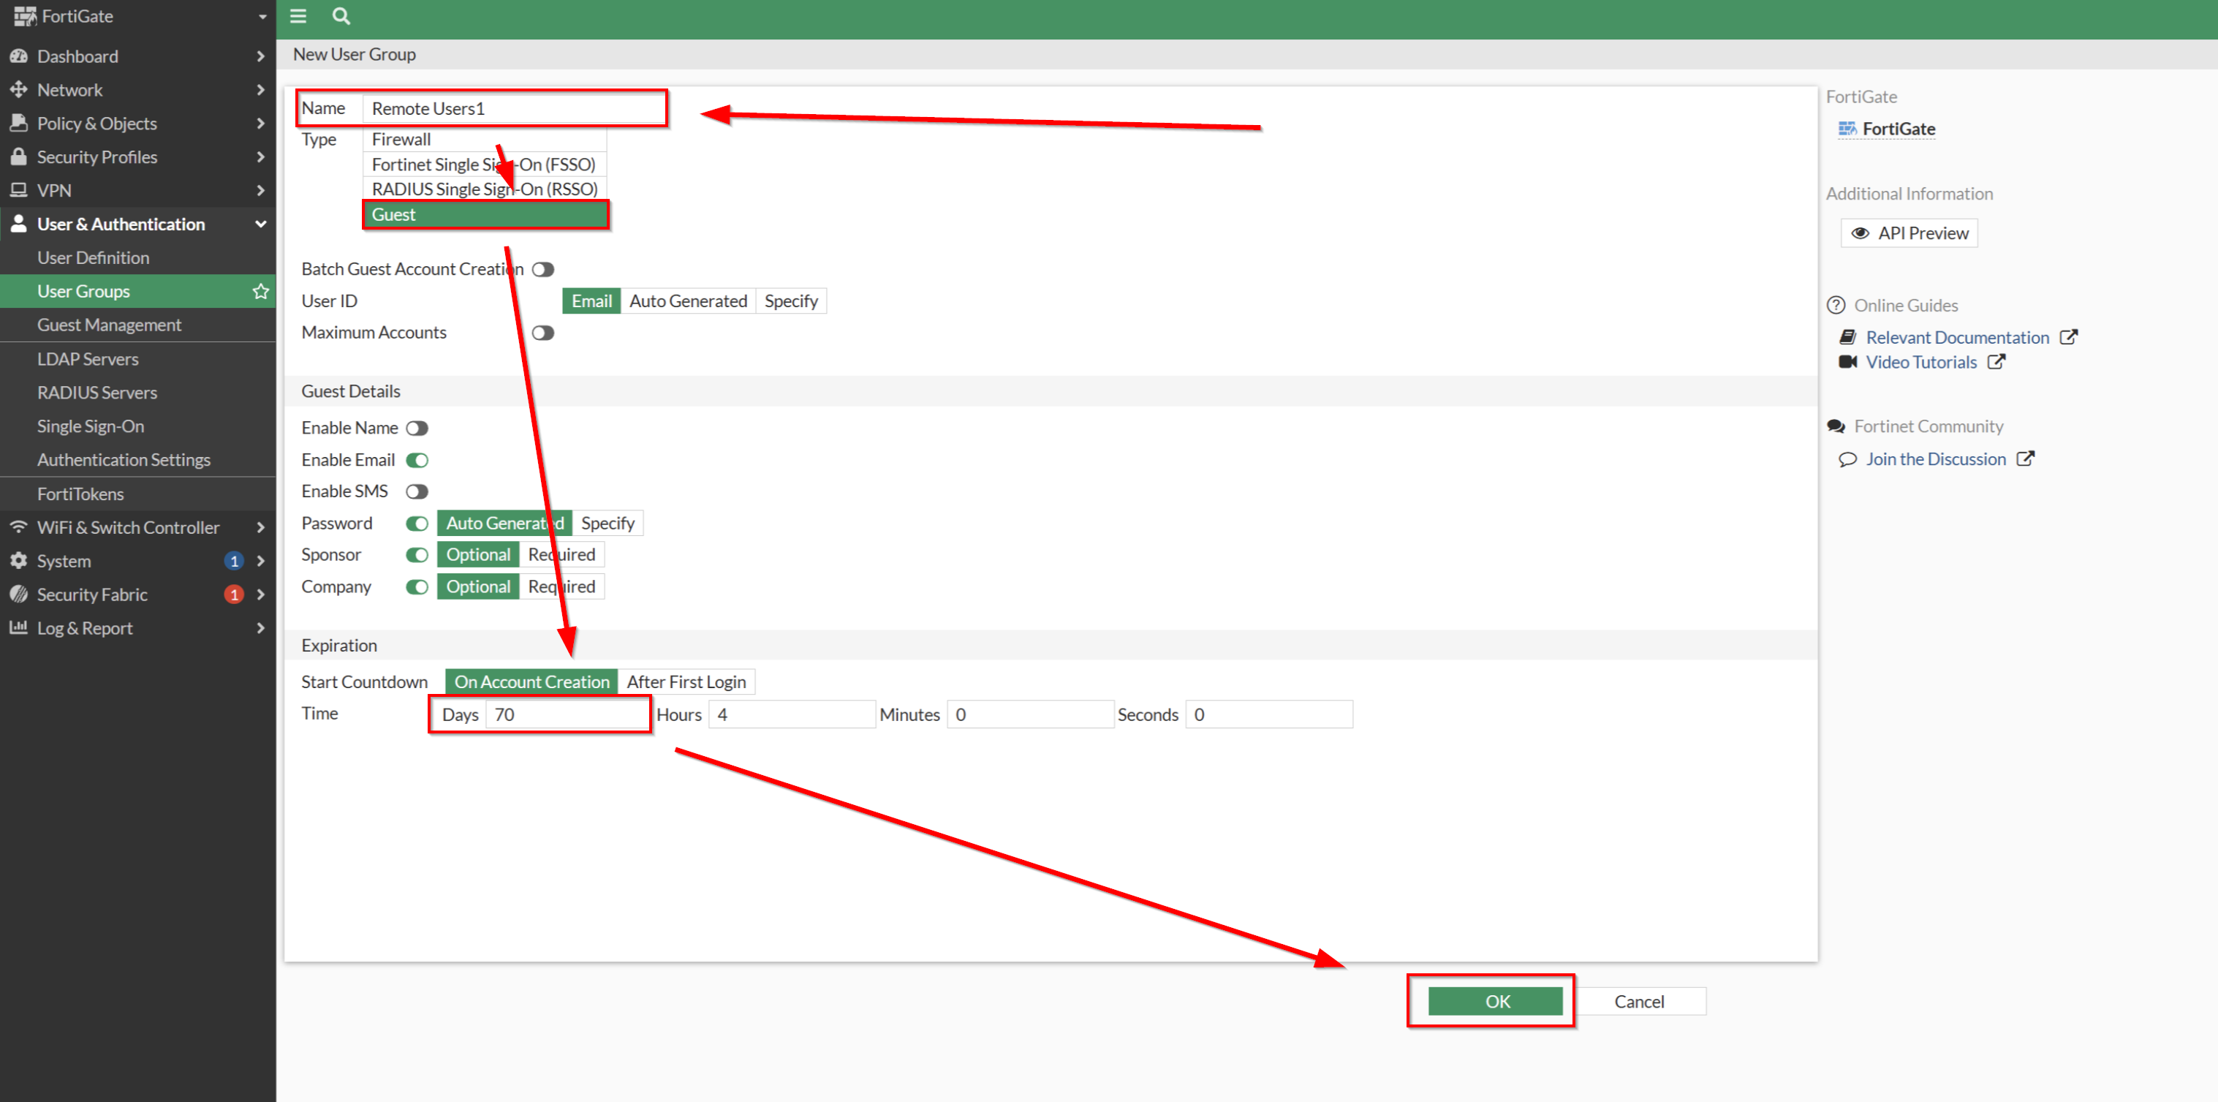

Next, we should define the user that is going to log into our VPN network for connectivity. Head over to Users & Authentication User Definition Create New.

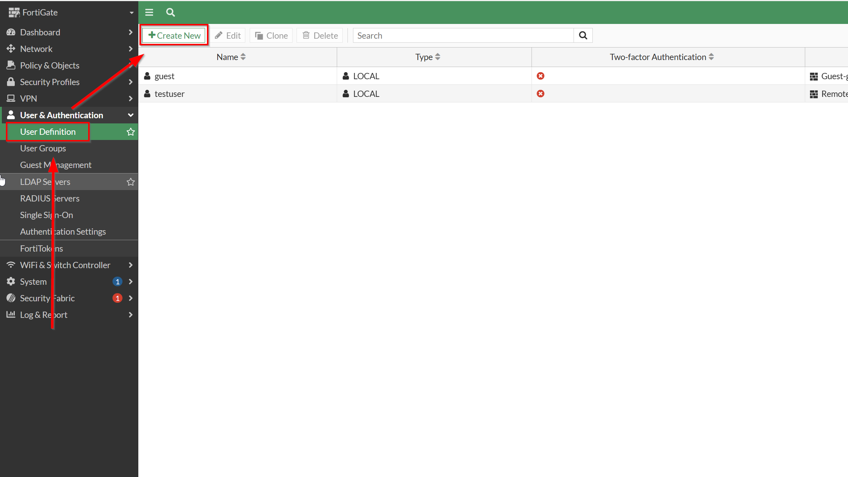

This process happens through multiple steps. Follow the following steps shown on the images down below.

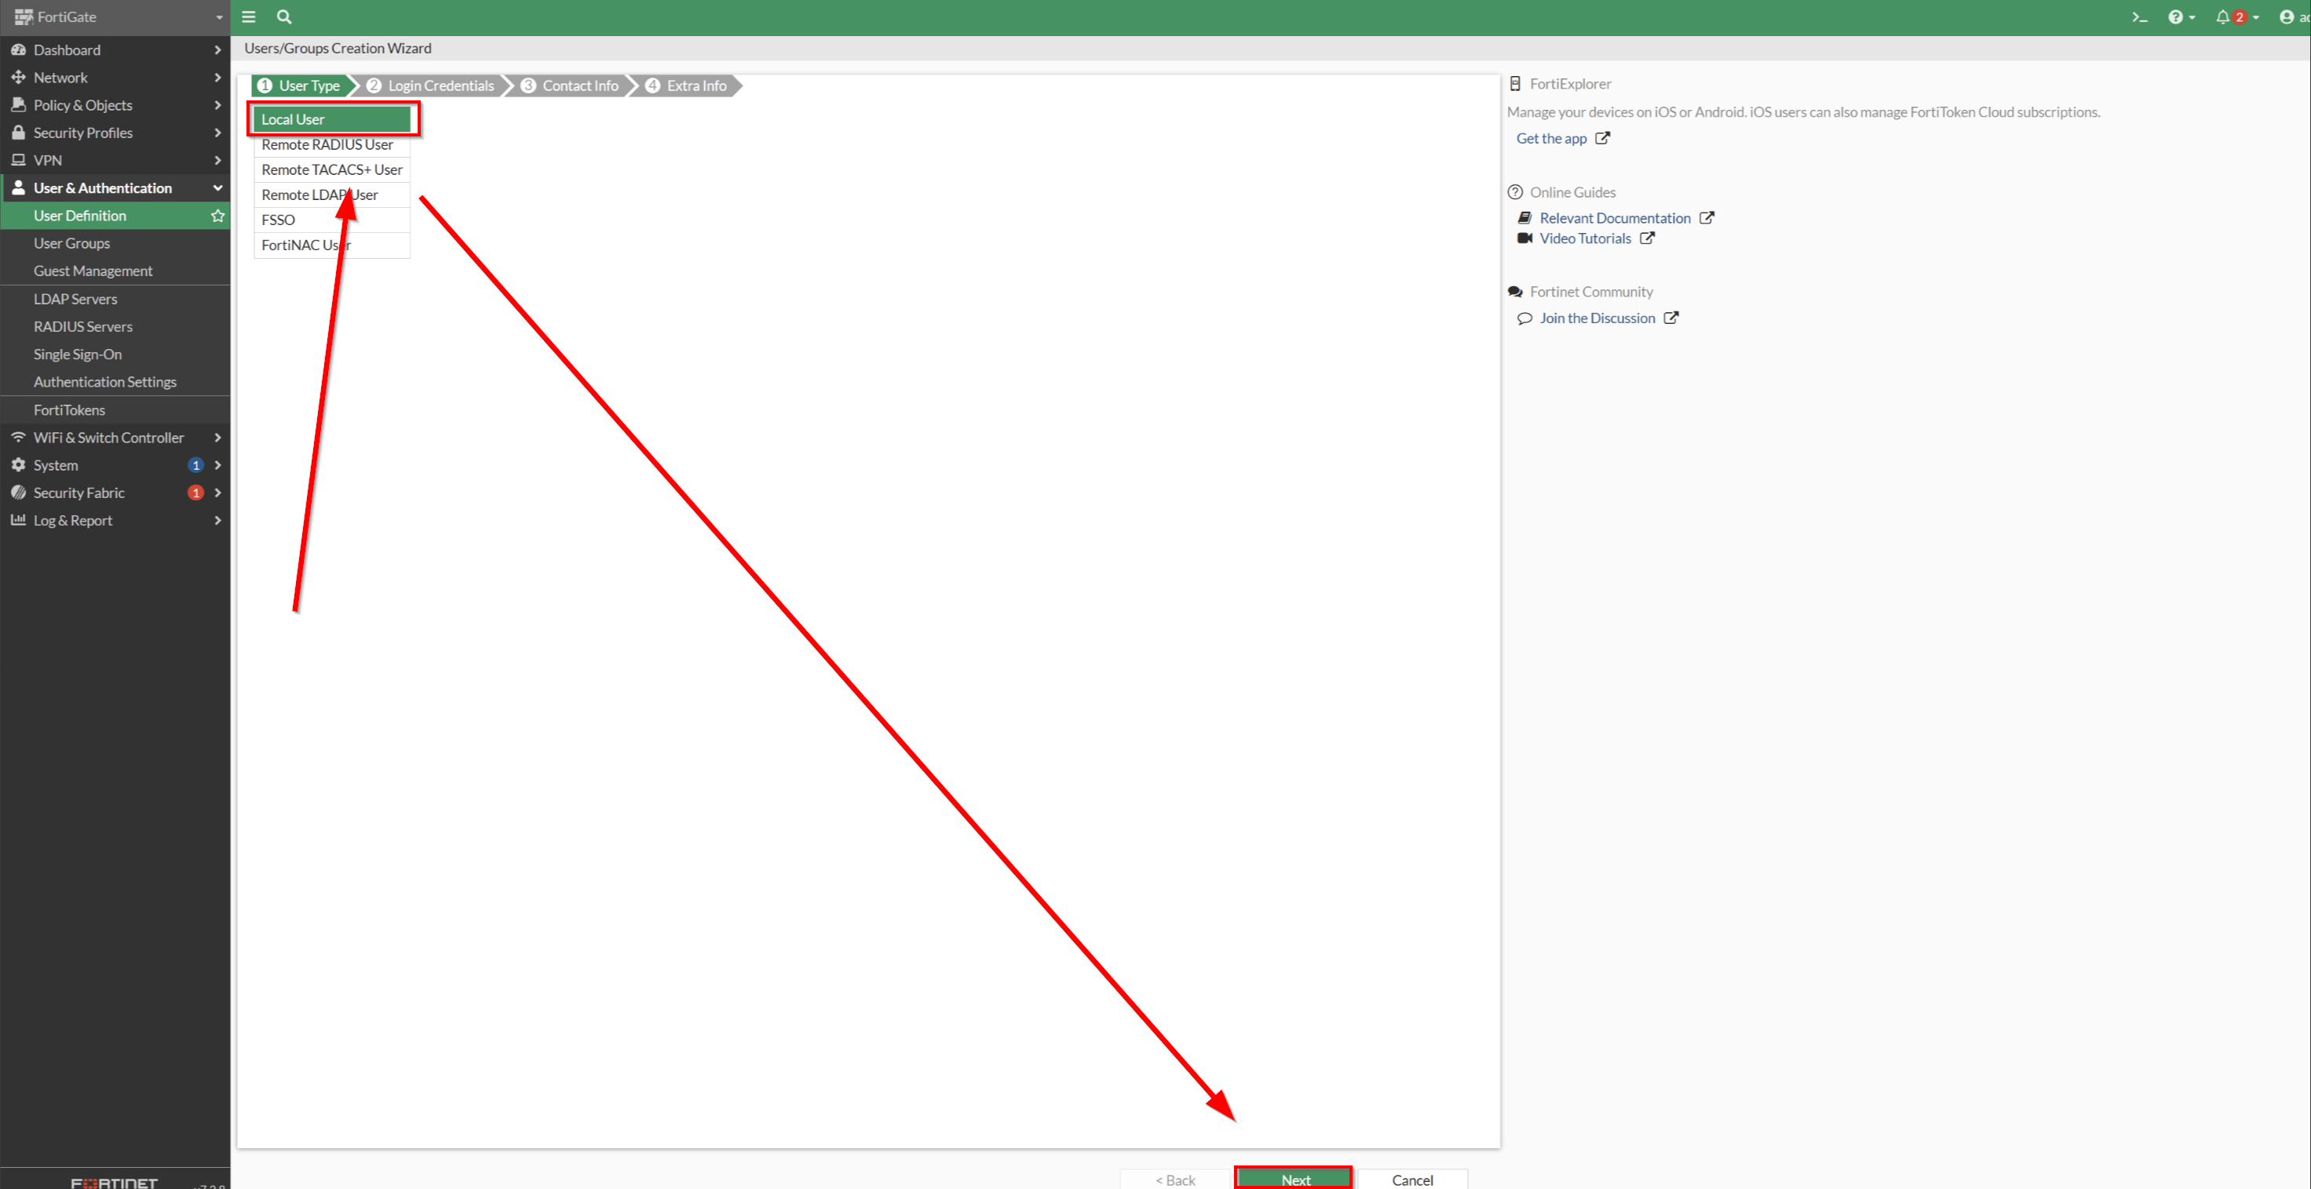

Note: for step 2, note down our Username and Password. You will need this when logging to VPN.

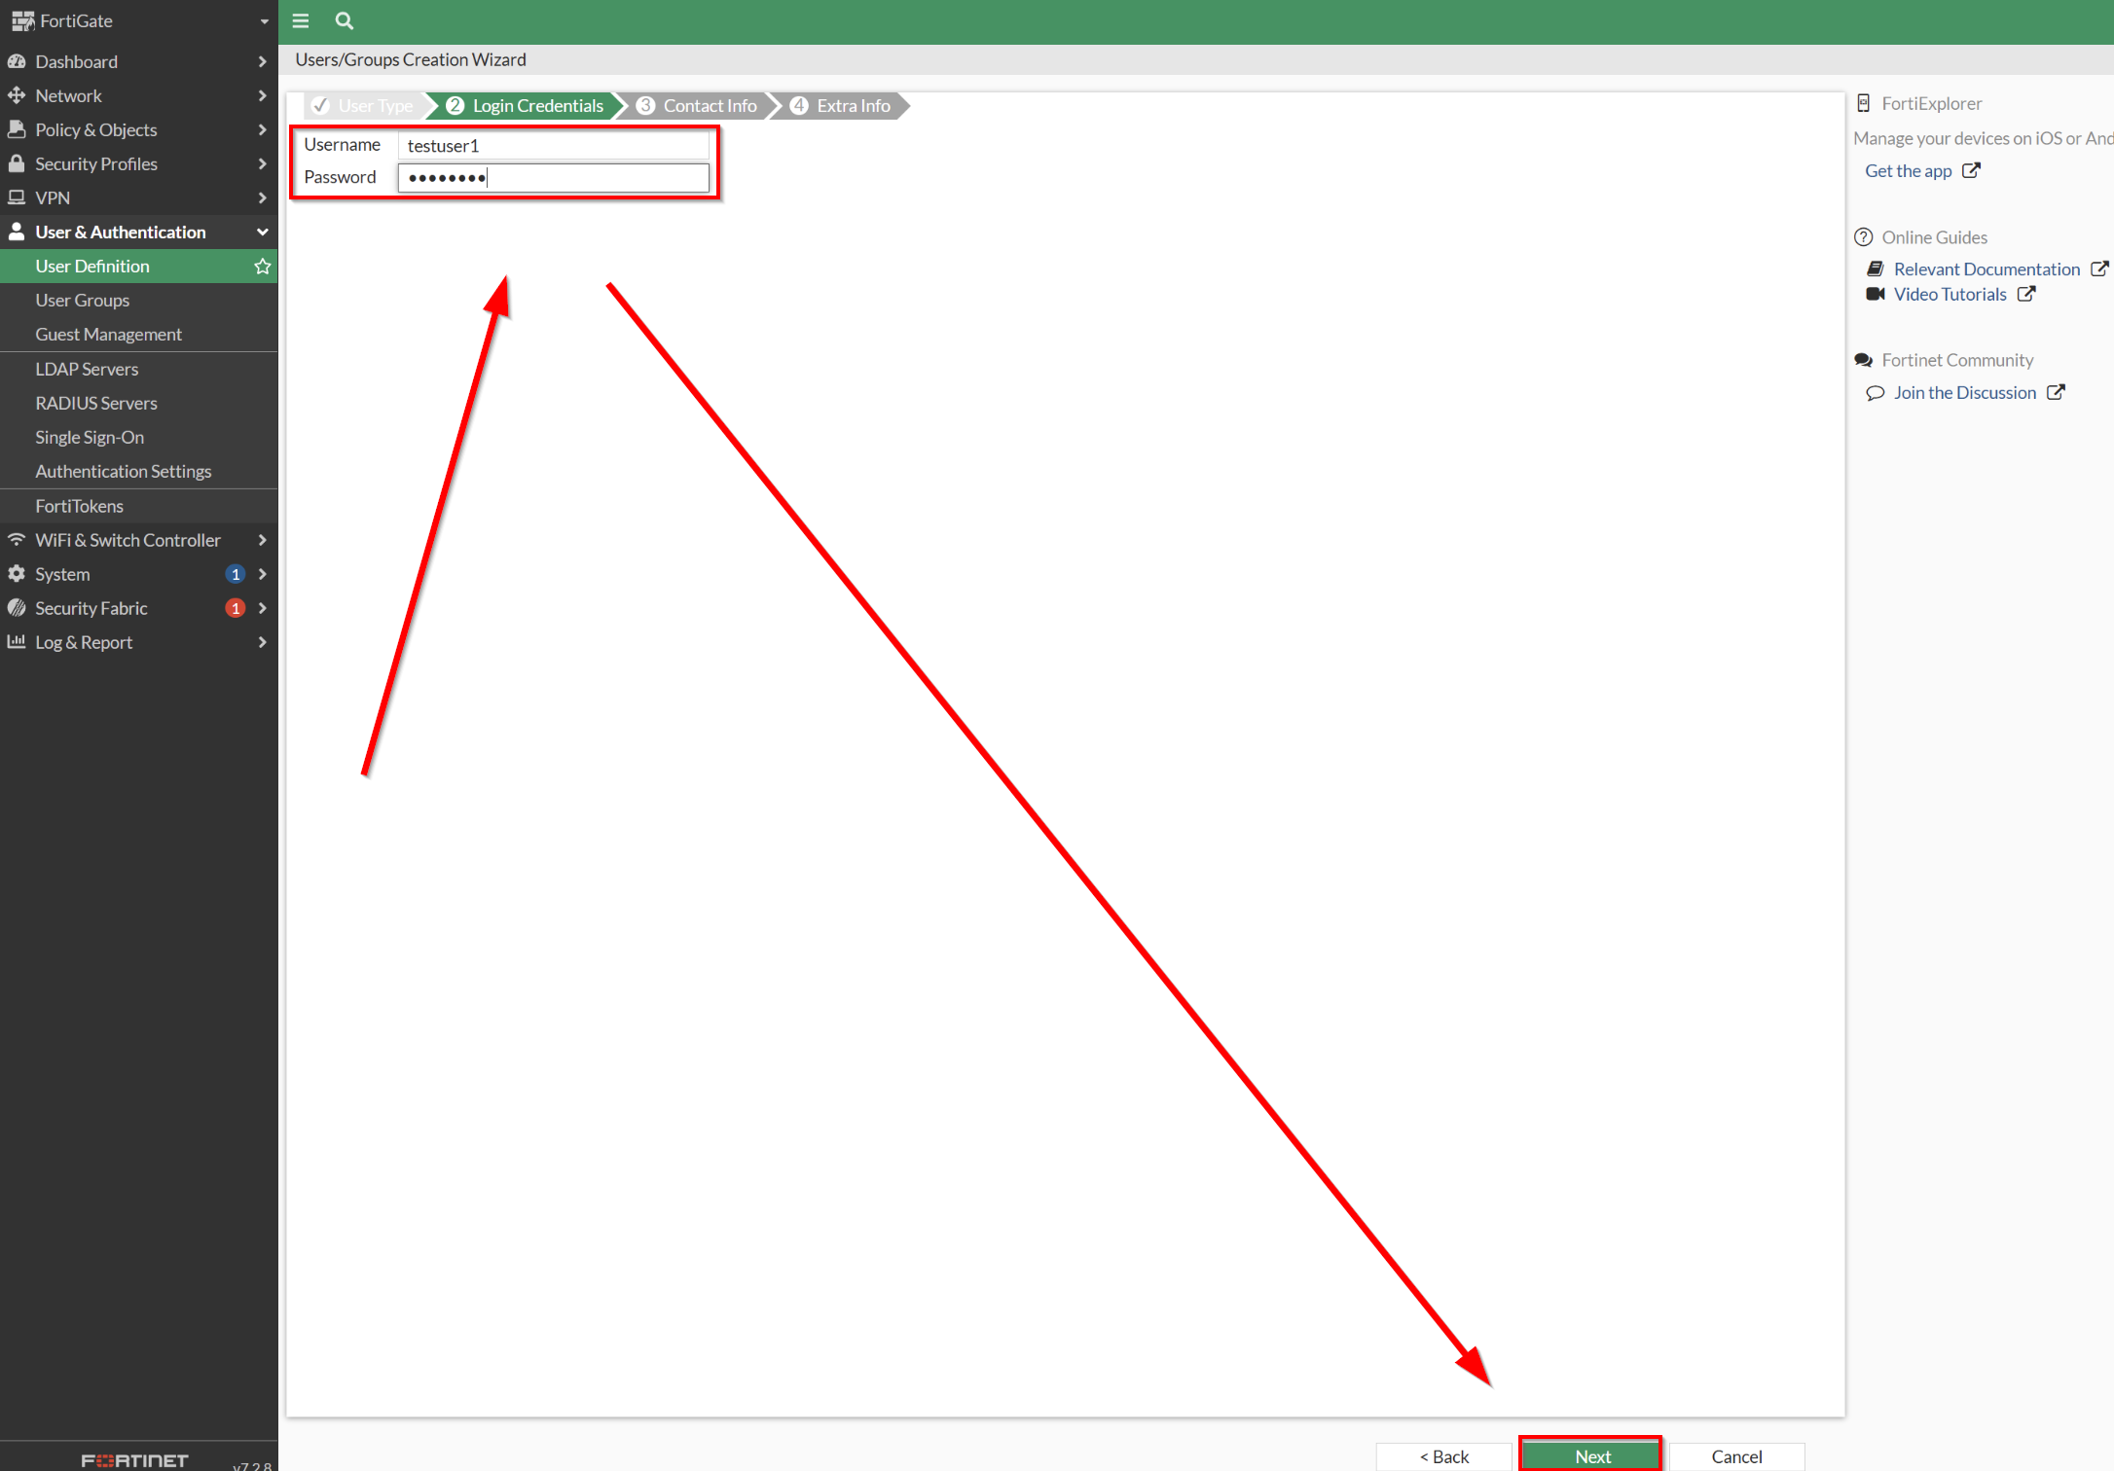

Even though Two-factor authentication is not required, it is highly encouraged. However, we wont be configuring Two-factor authentication for this demonstration.

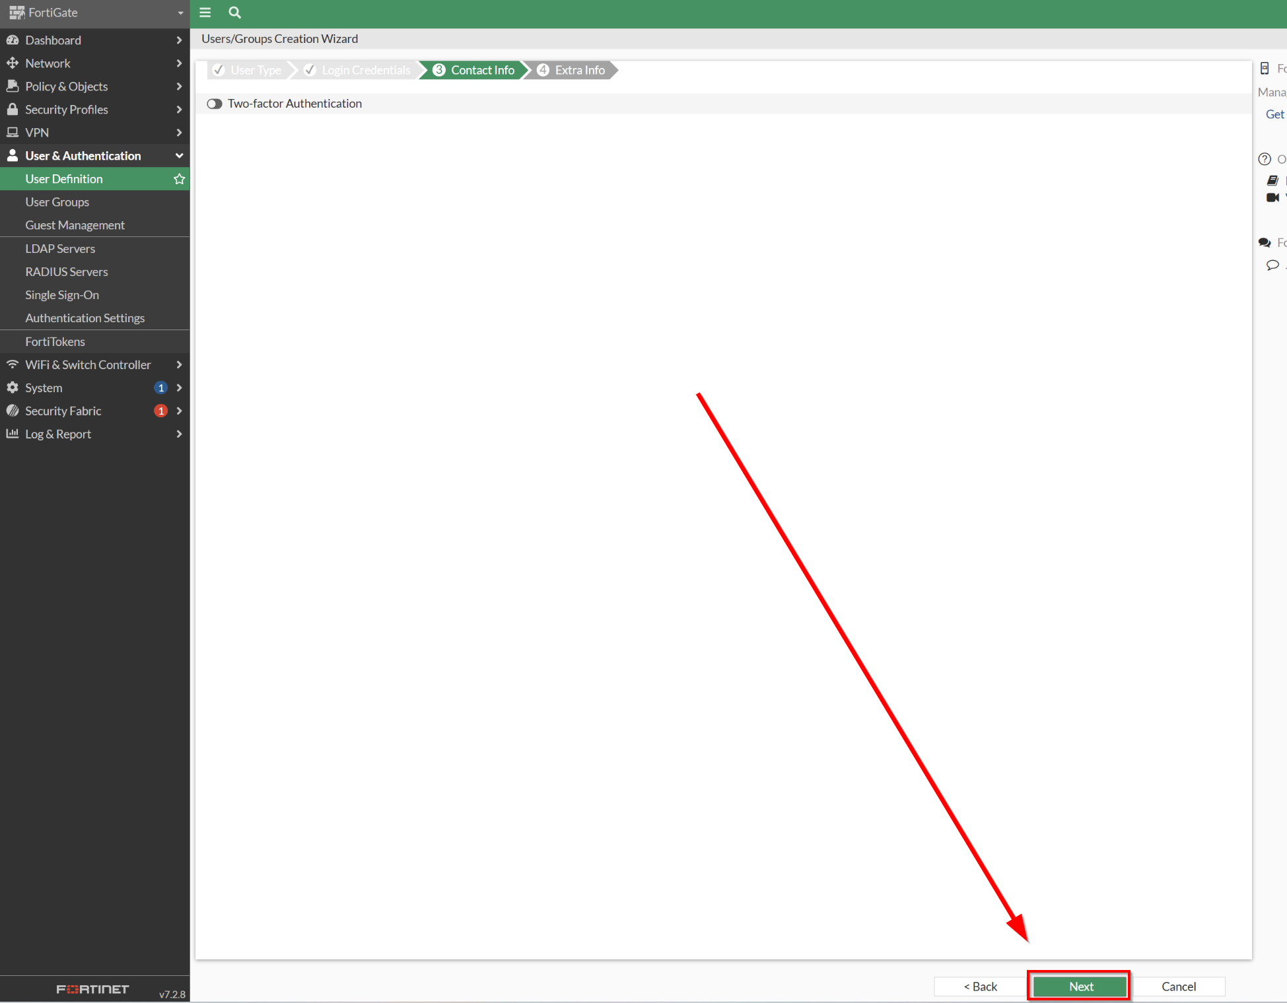
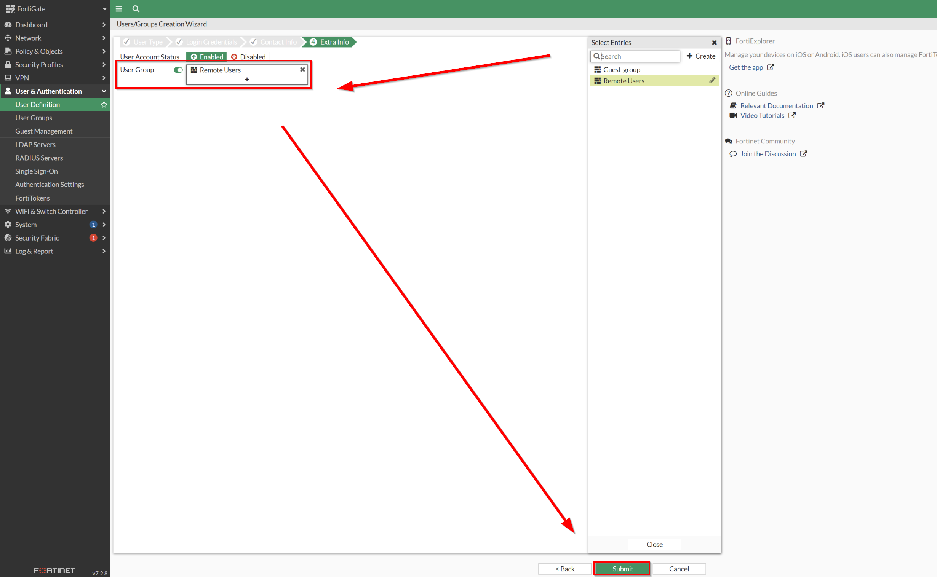

Next, head back into User & Authentication User Groups Remote Users.

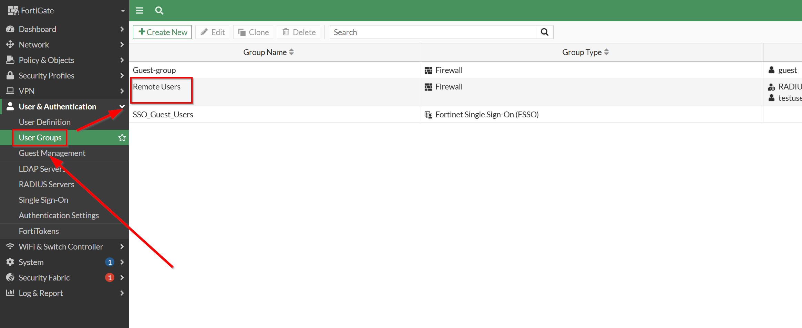

Make sure that the testuser is selected as its Members and also define a RADIUS server for its remote groups. Press OK when finalized. Note: boot up your radius server.

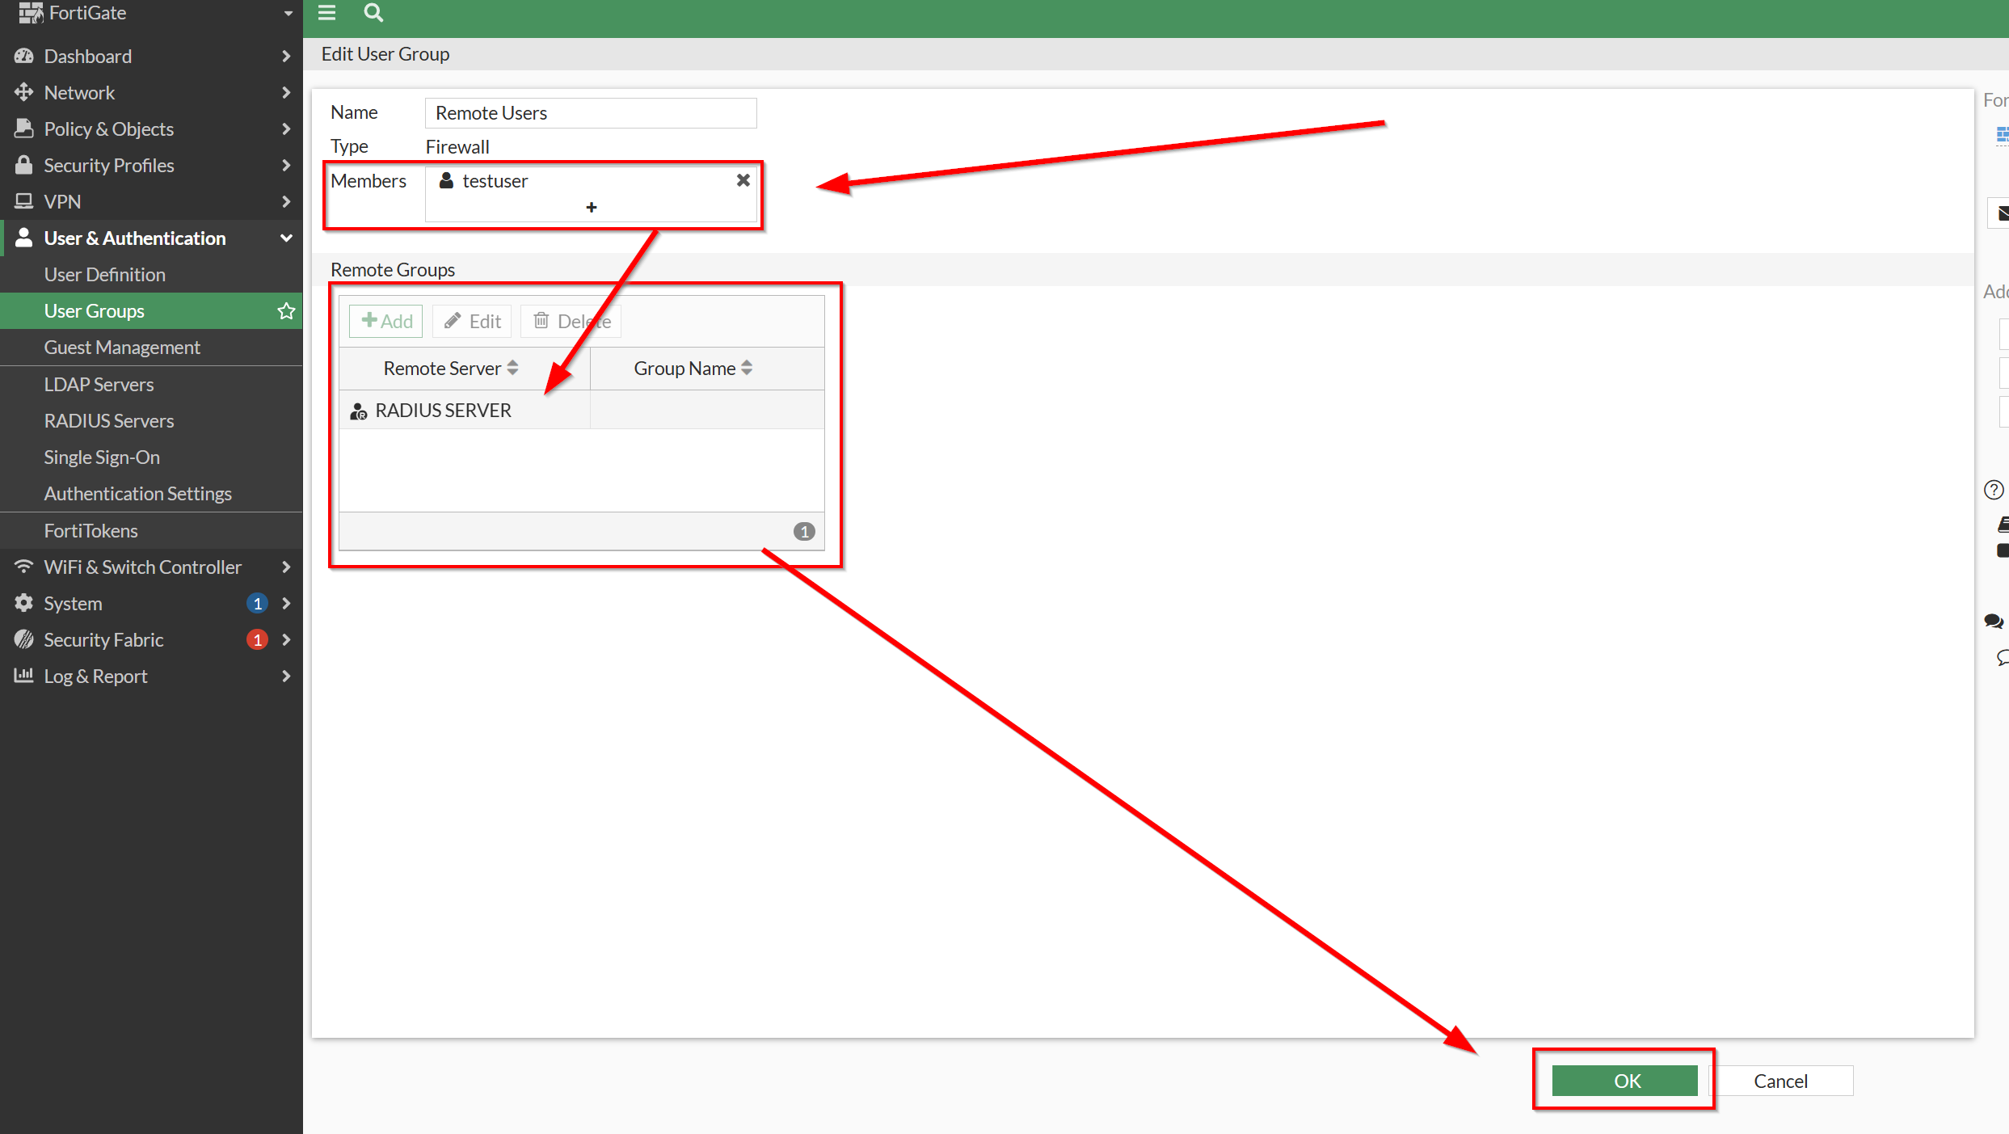

After that, head over to VPN SSL-VPN Settings. Here, follow the steps below to configure SSL VPN. Also, select our Remote Users and put it under tunnel-access for encryption, and direct all other Users/Groups to web-access. When finalized, hit Apply.

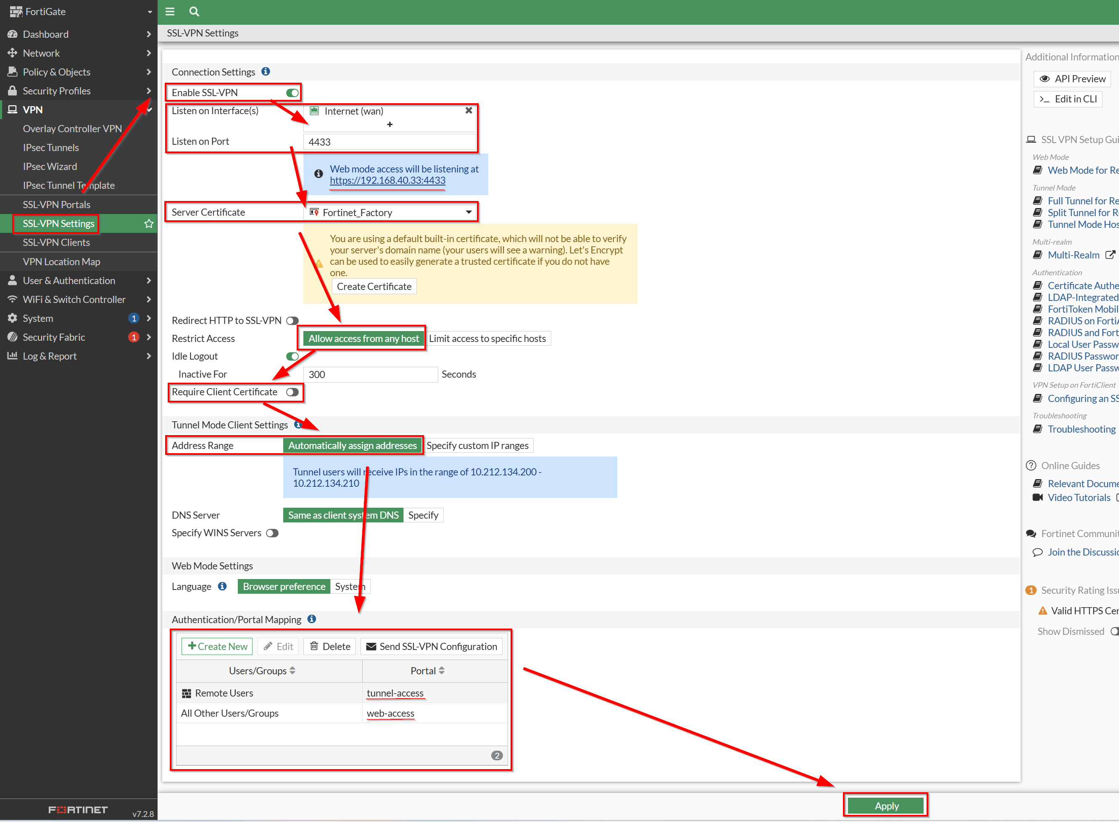

Save the address posted in the first blue section in the screenshots above (likely different addresses on your end).

Then, transfer over to your other external device and access and paste in the address you copied. This will direct you into the SSL-VPN Portal. Press Download FortiClient and proceed with the installation process.

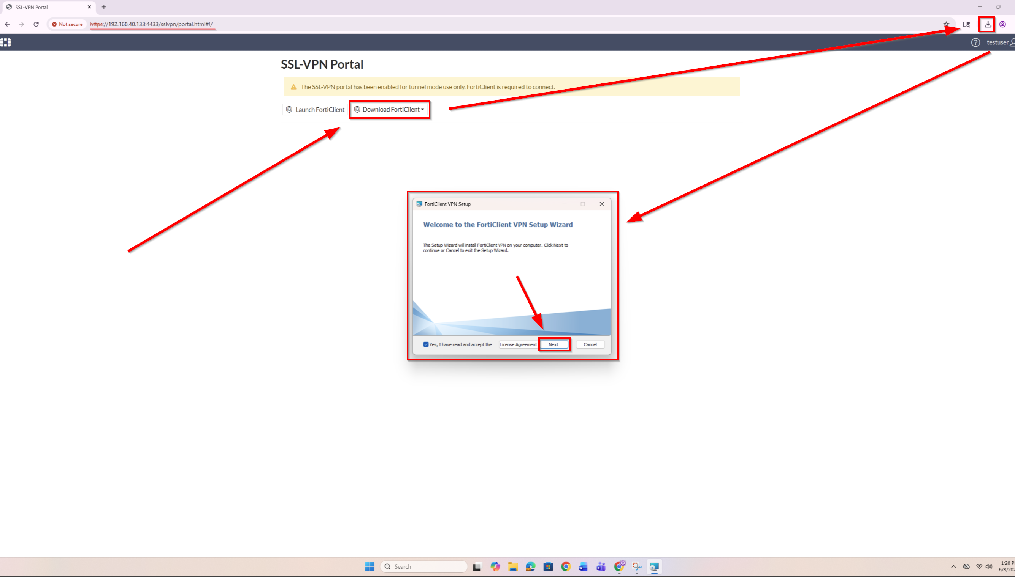
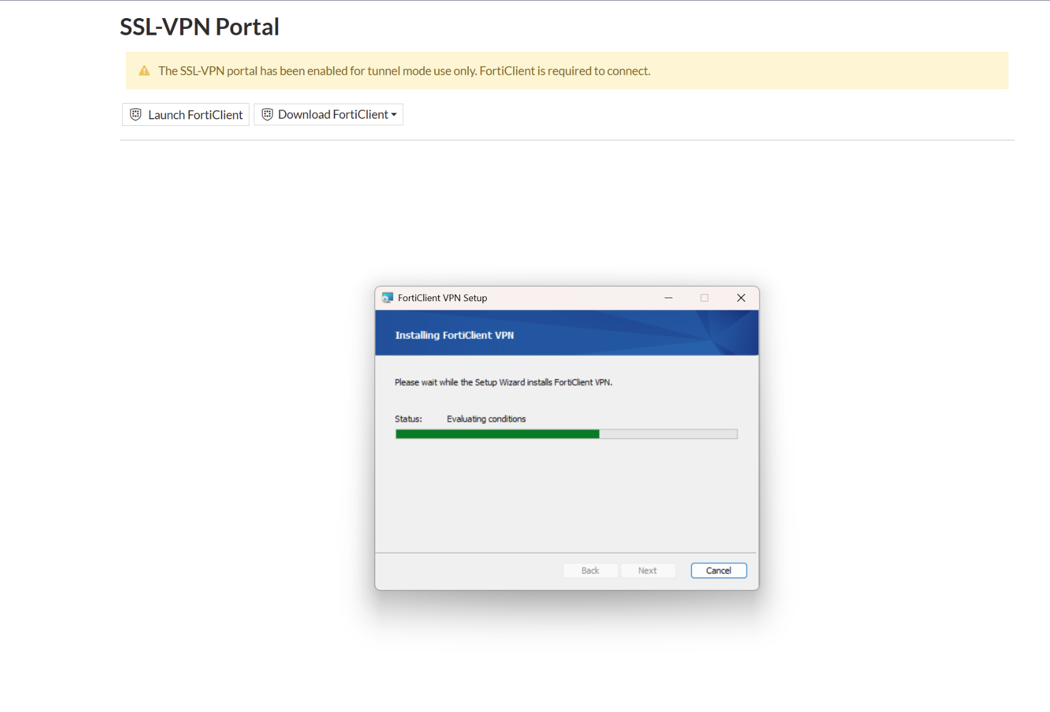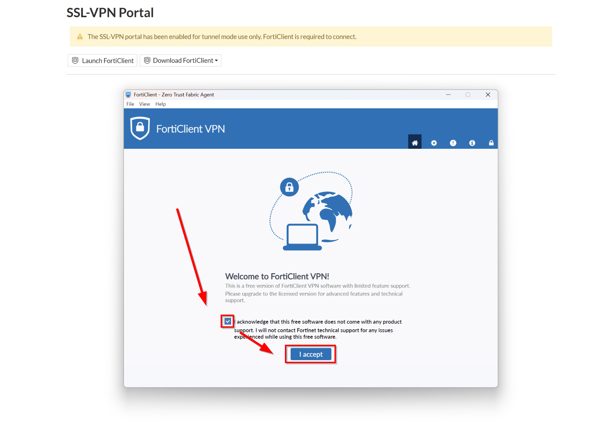

Proceed and press on Configure VPN.

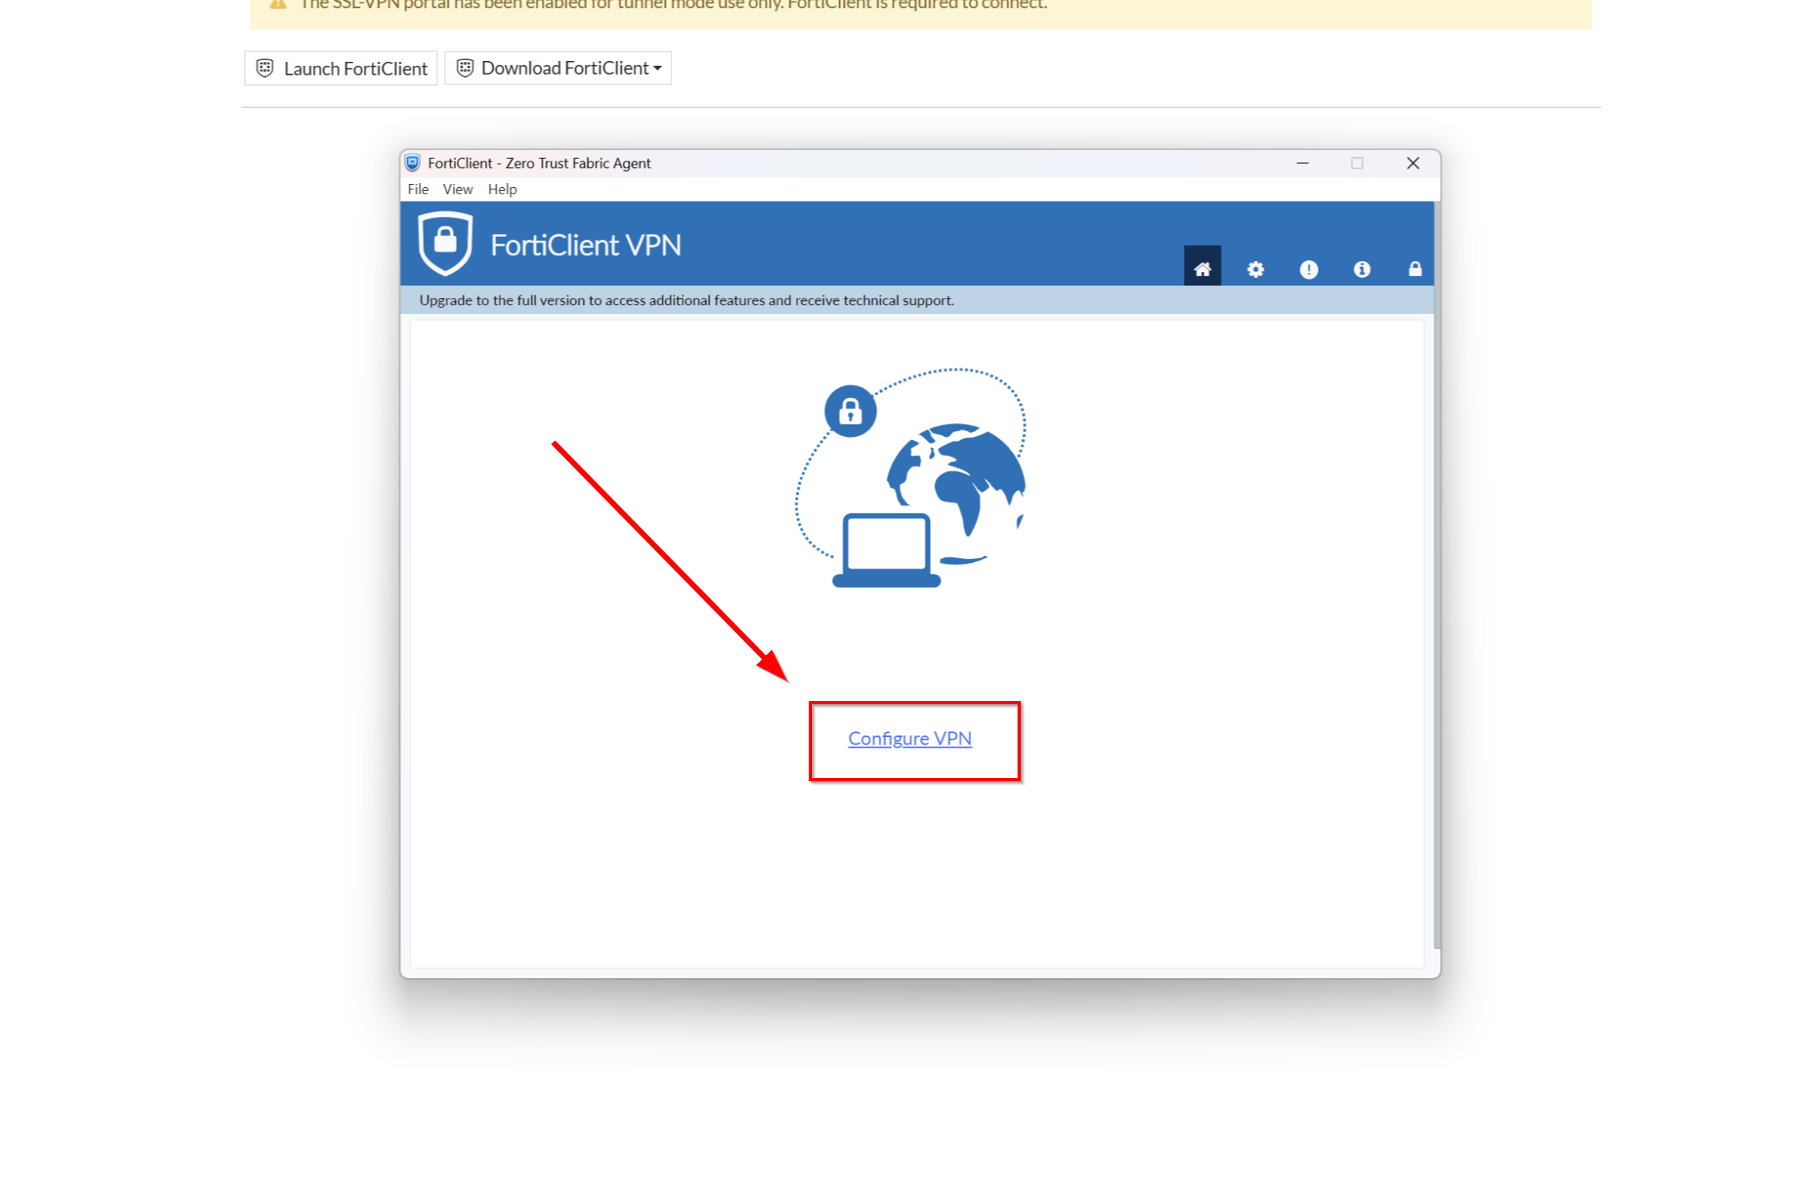
Here, login with your saved credentials from earlier. The VPN Name could be anything. Press Connect.

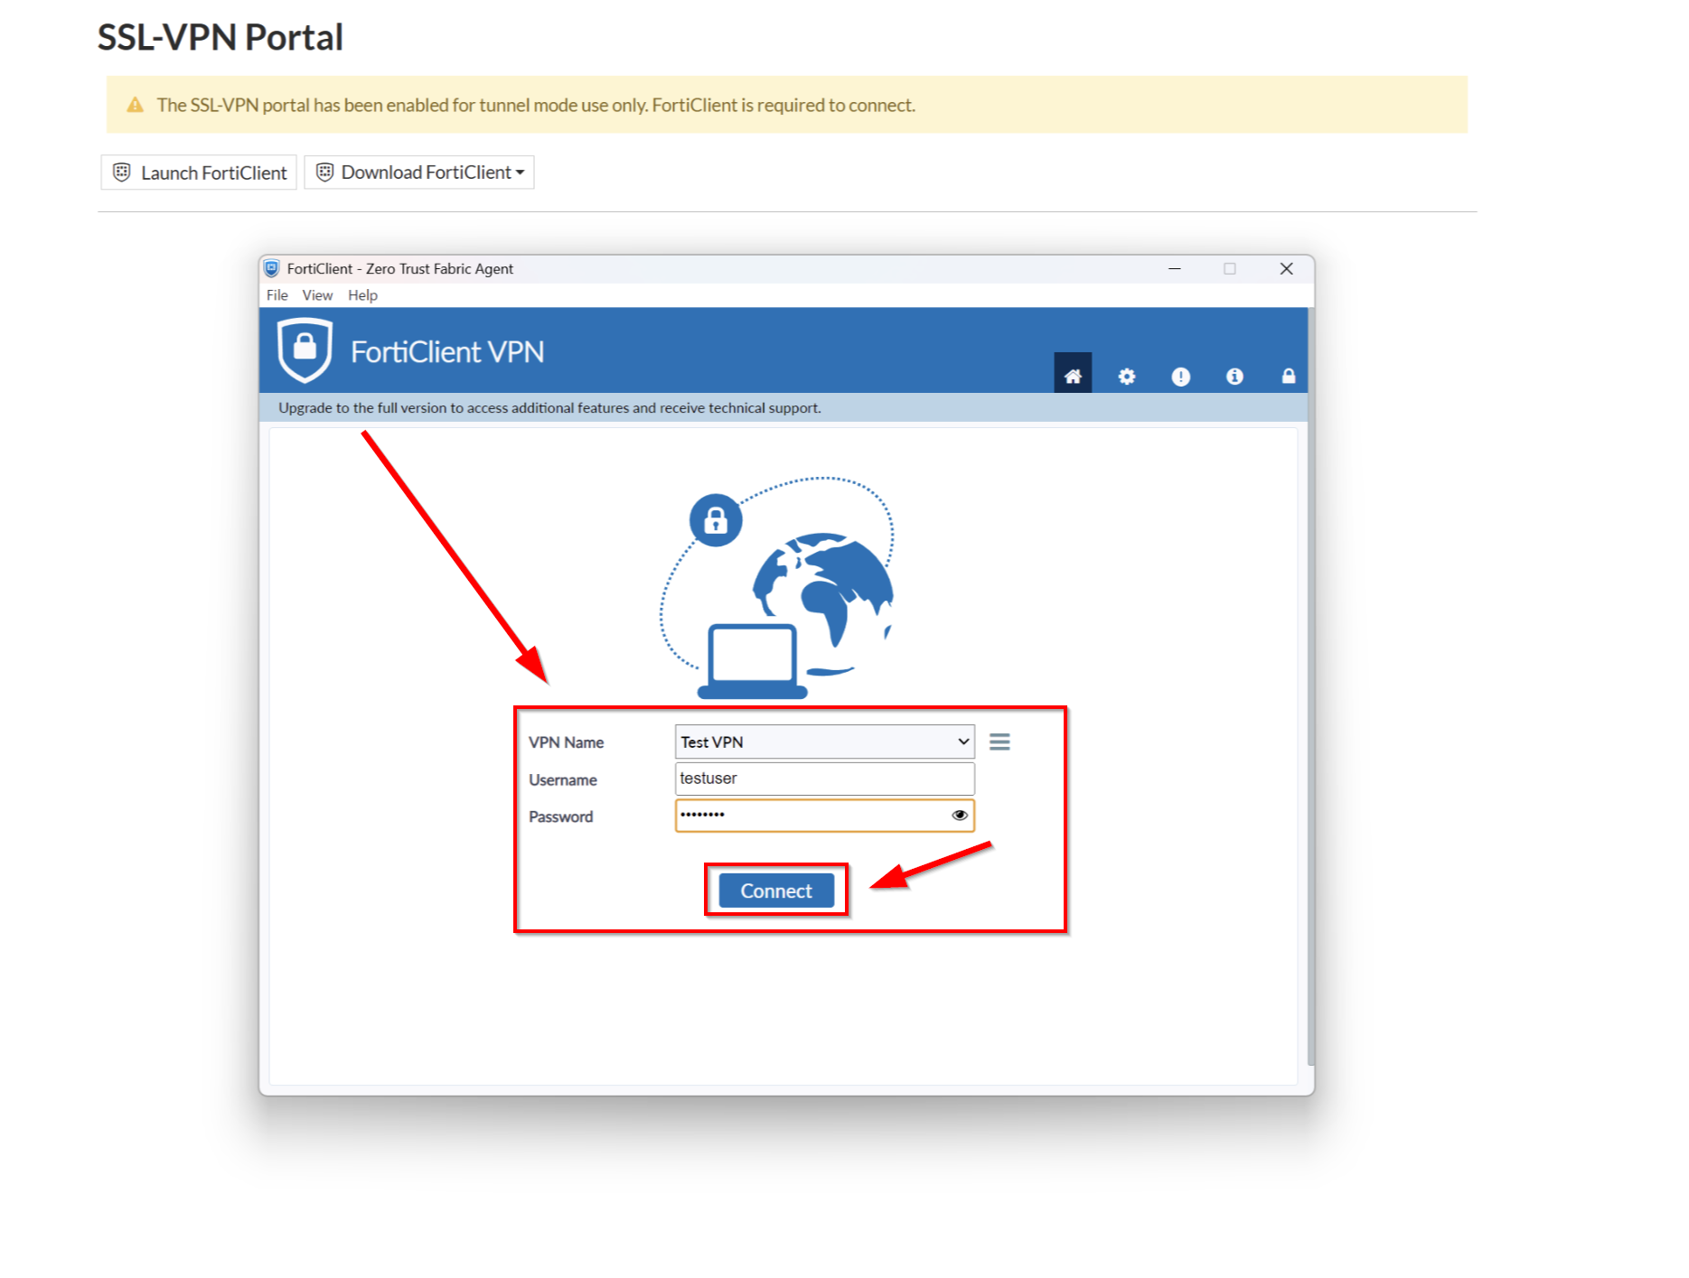

To check if your VPN is properly connected, click the arrow on the bottom right of your screen and right click on FortiClient Open FortiClient Console. This will prompt a screen where it shows if you are connected to FortiClient VPN or not.
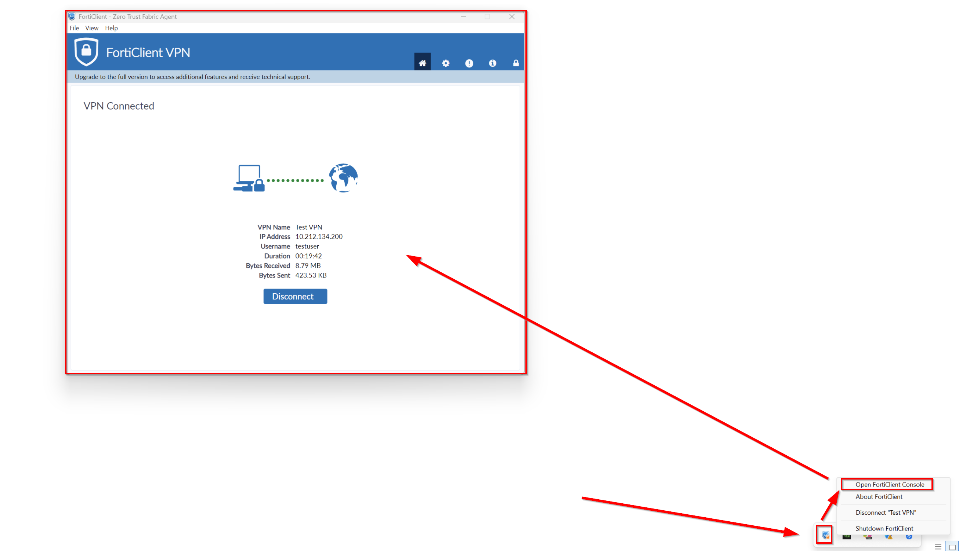

Then, go back to the Desktop that is used to be remotely accessed. Turn Remote Desktop on.

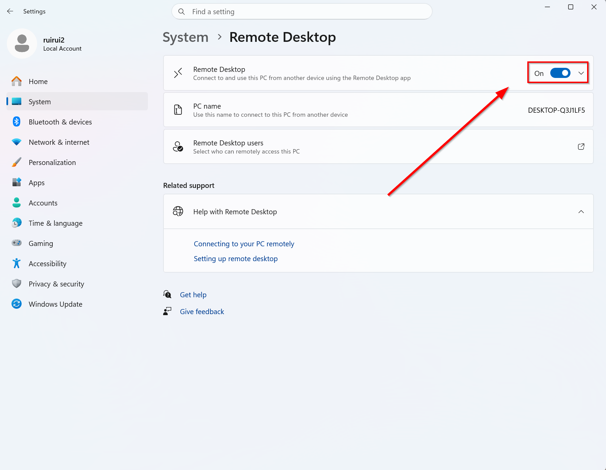

Then, go to Command Prompt and type in ipconfig. Copy your IP Address from the firewall and save it.

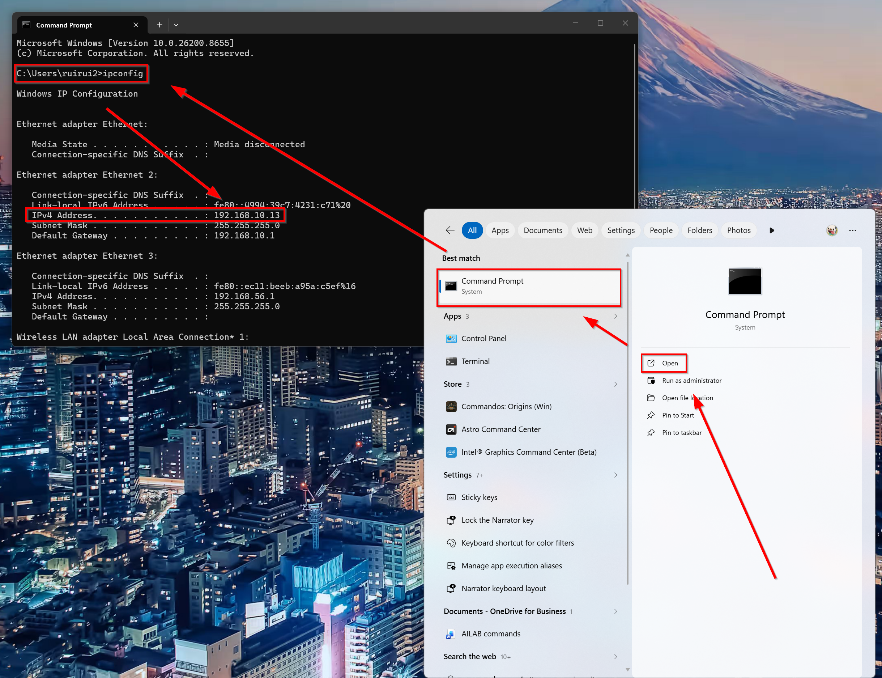

Go back to your external PC and head over to Remote Desktop Connection. Type in your copied IP Address into the Computer section field and hit Connect.

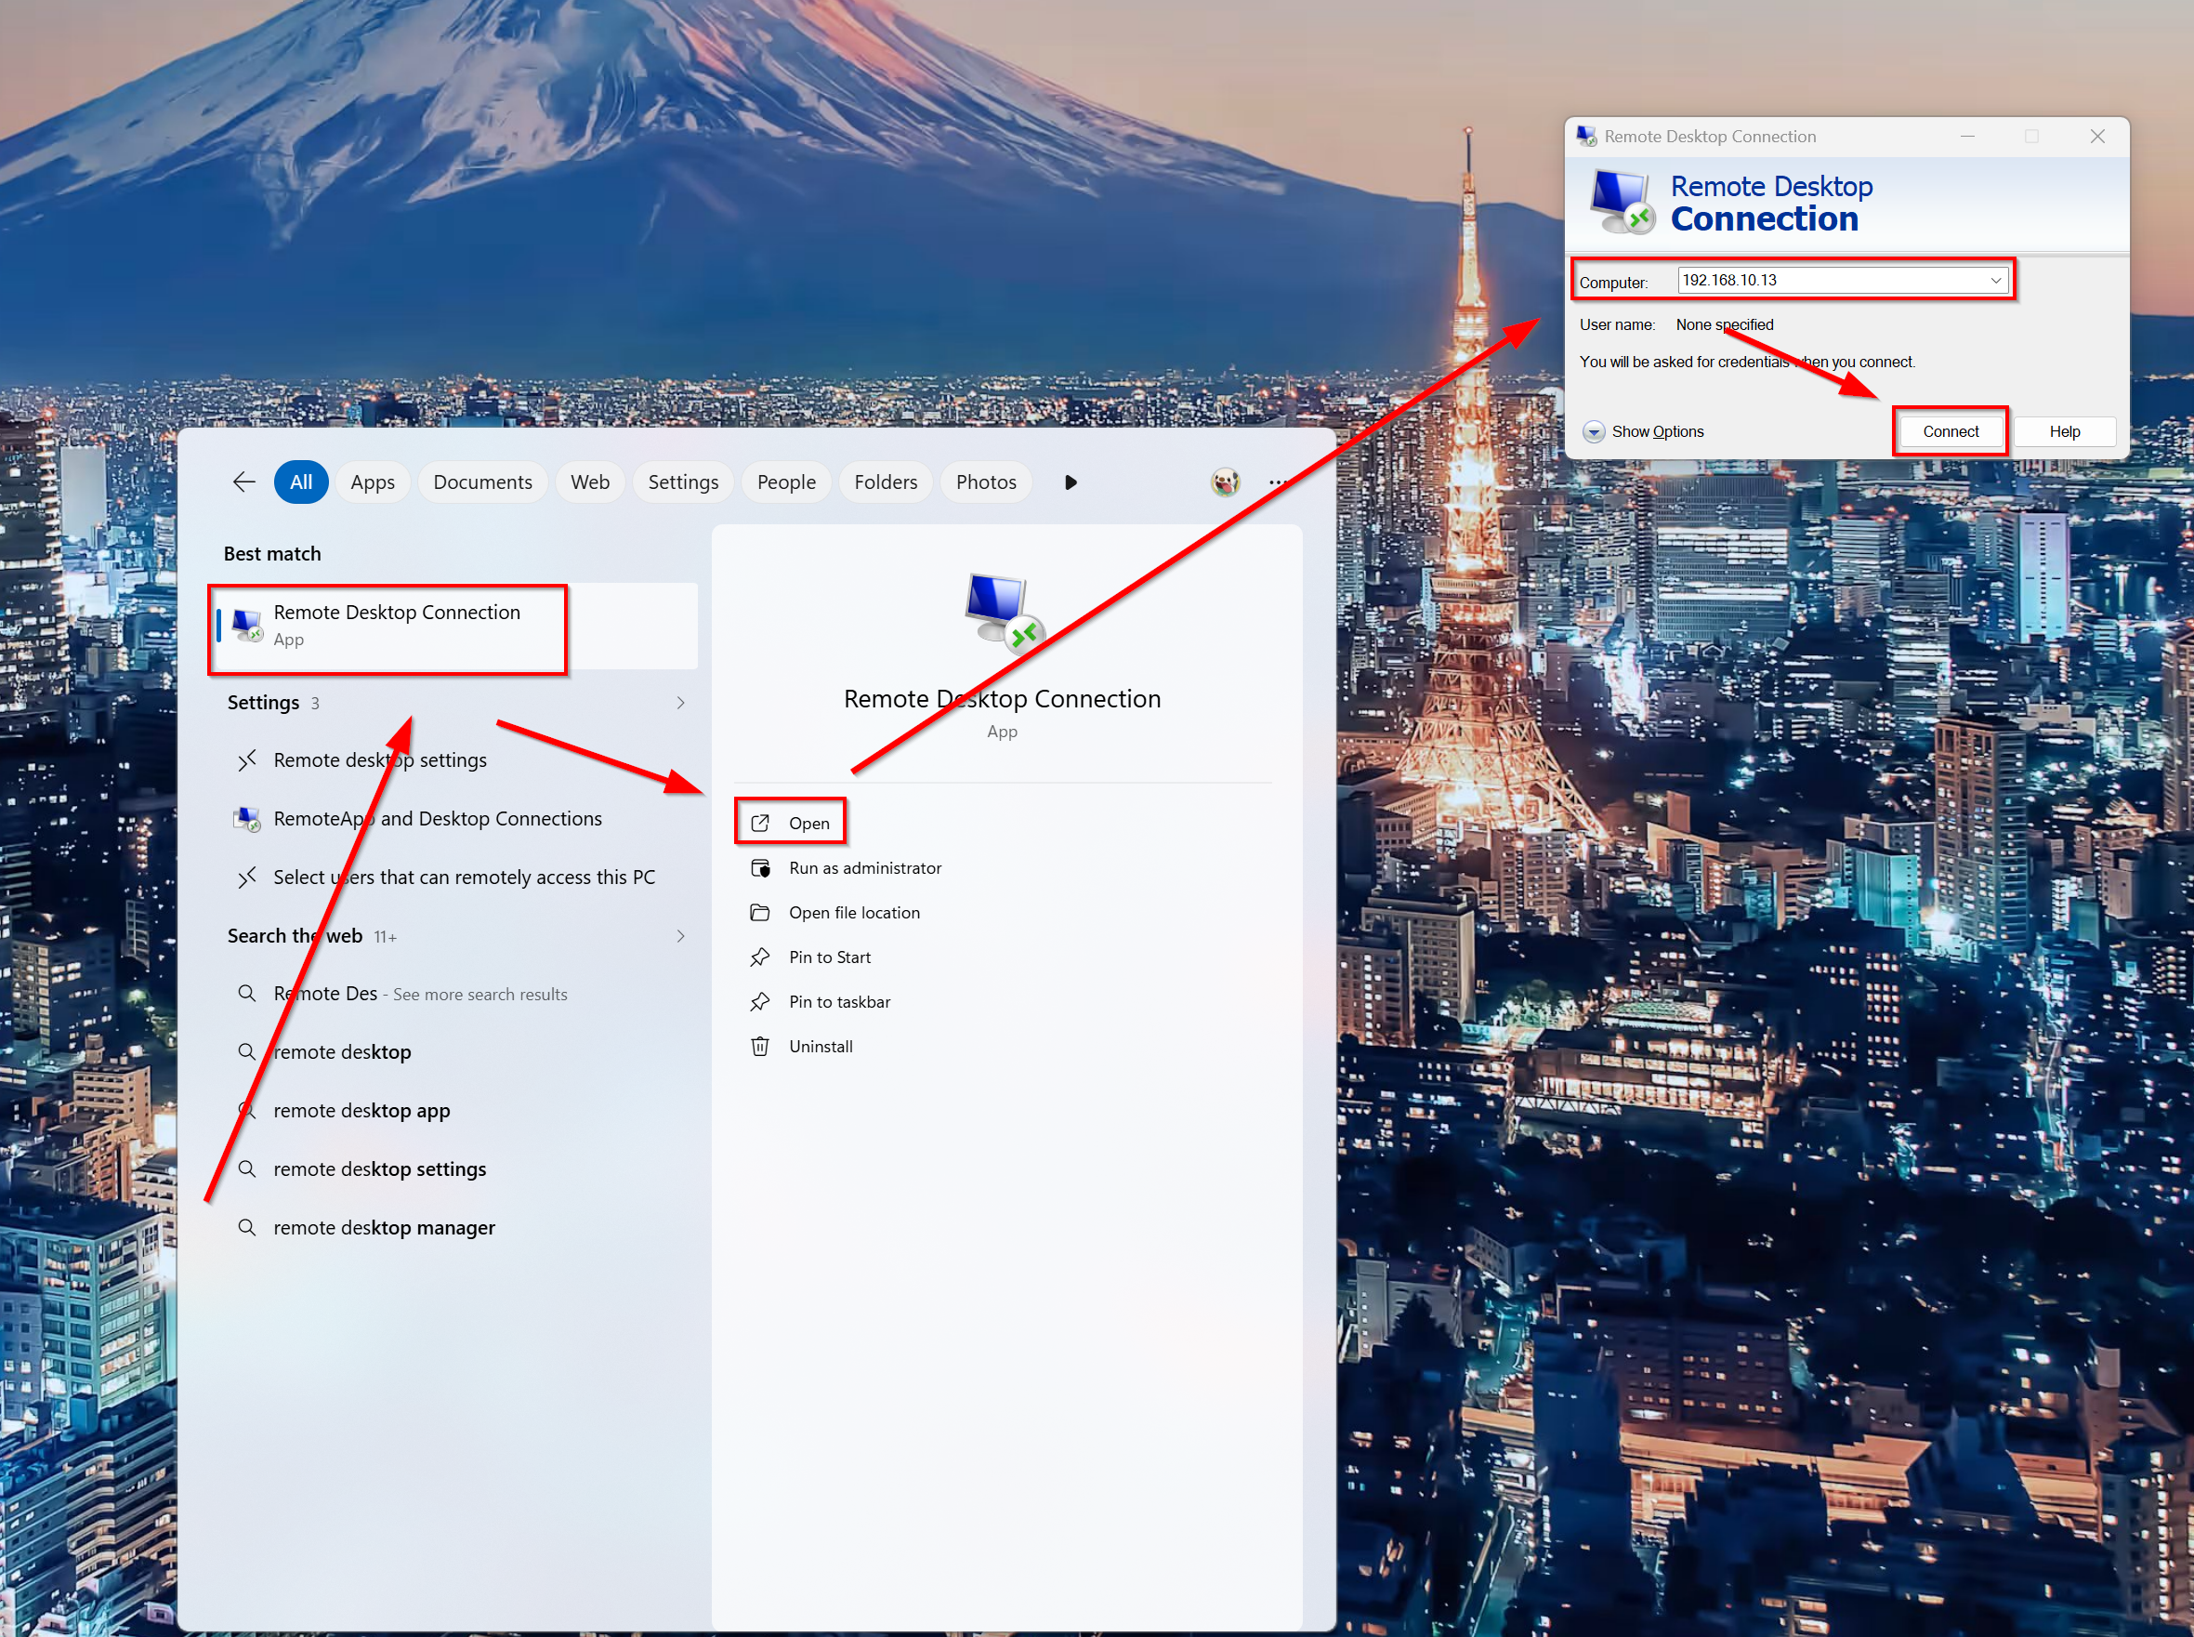

If you were able to access PC1 from your external PC, then you have successfully remotely accessed your PC using Fortinet’s VPN tunnel connection!

Problems:

One of the biggest problems is creating the firewall policy. We could not remotely access from PC1 to PC2, and it was a small mistake on our firewall policy side. When we found out that we configured our SSL VPN traffic to our WAN instead of LAN, we had a great laugh. After quickly fixing this issue, the remote access feature worked instantly, marking our completion of our lab.

Conclusion:

In conclusion, configuring VPN for Fortinet allowed us to technically figure out what VPN really means and how SSL/TLS comes to play when it comes to encryption and remote access. Despite configuring firewall policies for other labs, we have especially appreciated and deepened our knowledge of how to configure inbound and outbound traffic for policies tailored to different processes like SSL VPN to the LAN network.

